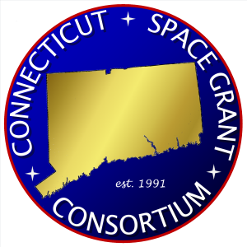

NASA CT SPACE GRANT CONSORTIUM

Informal Education Grant Application

Indicate type of application:
☐ Project/Event ☐ Internship

Project/Event or Internship Title:
Project/Event or Internship Description: (250 word maximum)

Applicant Contact Information:
Name:
Title:
Organization:
Email:
Phone:
Address:
City/State/Zip Code:

Project/Event Activity or Internship Date(s) (mm/dd/yyyy):
Start Date: |  | End Date:

What is the expected duration of project/event:
☐ Short Event (< 2 Days) ☐ Long Event (>2 Days)
☐ Multi-Month (Semester/ Quarter) ☐ Year-Long (12 Months)

Location of Project/Event:
Name:
Address:
City/State/Zip Code:
Enter the anticipated number of participants that will participate in project/event or benefit from internship:
Participant Type |  | Count | Participant Type | Count
K-12 Teachers |  |  | Higher Education
K-12 Students |  |  | Other Community Members
Total Participants

Describe the involvement of K-12, higher education, and other community members in this project/event or internship (if applicable):

Provide a timeline for this project/event or internship:

Complete budget (see Appendix A) and include a brief narrative of expenditures and in-kind contribution(s). Please note: the budget should provide at minimum a 1:1 match (direct or in-kind) (e.g., if you are requesting $500 in funding, a minimum $500 match should be provided by organization):

Applicant Signature: |  | Date:
Applicant Name:

Appendix A: Budget

Item | Request | Match | Total
Salary/stipend
Equipment | Not permitted
Supplies
Transportation
Facility rental/usage
Food
Other (please specifiy)
Total

Submission Instructions:
- Complete Informal Education Grant Application
- Send Informal Education Grant Application in PDF format to ctspgrant@hartford.edu

Important Information:
- Application priority deadlines are March 1st (for award period April 1st to June 30th) and June 1st (for award period July 1st to December 31st); applications received after priority deadlines will be reviewed on a rolling basis and awarded if funds are available
- You should receive notice of award within 3 weeks of submission
- If awarded, you can anticipate receiving funds approximately 6-8 weeks after submission
- You must prepare a short post-award description of the outcomes of the project/event

