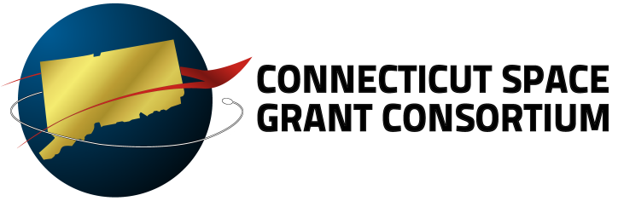

Graduate Research Fellowship
Application Cover Sheet 2013-2014 Program Year

The information provided in this form will be used to help the CT Space Grant Advisory Board’s Selection Committee in their awarding selection review process.

Proposal Format and Checklist: Submit a complete application as a single PDF file via email to csgcinfo@hartford.edu. Components of the Graduate Fellowship Application include:

- Applicant Contact/Demographic Information – This information is used separately for blind reporting to NASA.
- Abstract - Must include a paragraph on relevance to aerospace research and/or one of NASA’s strategic enterprises.
- Graduate Research Fellowship Application Cover Sheet
- Narrative –5 double-spaced pages maximum – additional pages will not be reviewed. Please include a paragraph describing your spending plan and the period of proposed fellowship performance (reminder: Space Grant Fellowship recipients cannot receive another federal fellowship or traineeship while receiving a Space Grant fellowship.)
- Resume/Curriculum Vitae –One page maximum
- Two Letters of Recommendation - 1 must be from a research advisor. This advisor’s letter should include a brief description (couple of sentences) on how the grad student will be working for them and how they will support their NASA-related research. (Note: faculty who wish to submit confidential letters of recommendation may email those to csgcinfo@hartford.edu.)
- Student Transcript - Official is preferred; however, unofficial is acceptable if availability at the time of submission is a problem.

Please Type

Name: Mr. Ms. Mrs.
School:
Telephone:
Email:
Previous Space Grant Awards (please list all):
Citizenship: US Citizen Naturalized Citizen Foreign Student
Expected Date of Graduation: ________________________________

Proposed Period of Performance: Start Date: ___________ End Date: ___________

Please answer the following:

Title of Research: __________________________________________
Academic Advisor: ______________________________________
Advisor Phone/Email:________________________________________________________
--------------------------------------------------------------------------------------------------------------------
- Why are you interested in this research?

- Why should you be selected?

- Describe how your current academic and/or long-term professional interests/experience will be enhanced by this research.

I allow the CT Space Grant Consortium to post this application on their secured web page. This site will be accessible only to the Consortium Office and their Industrial Affiliates.

_______________________________________ __________________
Signature Date

Institutional  Certification | - Signatures below certify that the graduate student applicant’s institution approves of this application and acknowledges an understanding that if this proposal is awarded, the institution will need to enter into a sub-contract between itself and the University of Hartford before any NASA CT Space Grant Consortium funds can be disbursed.
Institutional Signature: ___________________________________ Date: ________
Advisor Signature: ______________________________________ Date: _______

