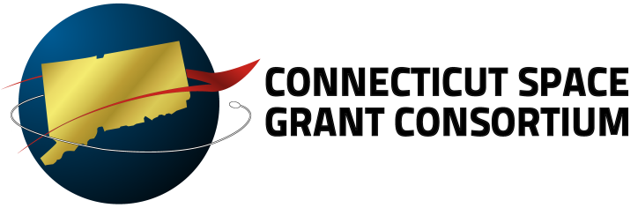

Rock-On Workshop – June 21 - 26, 2014, Wallops Flight Facility, VA
Application Cover Sheet to be submitted by Monday, March 17, 2014

*CT Space Grant will fund 3 attendees to this workshop. Your acceptance to the Rock-On Workshop is independent of the CT Space Grant Consortium’s decision to fund your participation.

The information provided in this form will be used to help the CT Space Grant Advisory Board’s Selection Committee in their awarding selection review process.

Proposal Format and Checklist: Submit a complete application as a single PDF file via email to csgcinfo@hartford.edu by 3-17-2014. Components of the Application include:

- Rock-On Workshop Application Cover Sheet
- Applicant Contact/Demographic Information - Note: this information is used separately for blind reporting to NASA.
- Resume/Curriculum Vitae - One page maximum.
- One Letter of Recommendation Must be from the student’s faculty advisor, signed and on letterhead. Applicants may submit additional letters of support. (Note: faculty/industry contacts who wish to submit confidential letters of recommendation may email those to csgcinfo@hartford.edu.)
- Student Transcript - Official is preferred; however, unofficial is acceptable if availability at the time of submission is a problem.
- Note: Rock-On requires that participants must know how to solder and must have practiced prior to attending the workshop. Also, you must be familiar with C, C++ or Arduino programming language. All code will be provided during the workshop.

Please Type

Name: Mr. Ms. Mrs.
School:
Telephone:
Email:
Previous Space Grant Awards (please list all):
Citizenship: US Citizen Naturalized Citizen Foreign Student
Year of Expected Graduation: ______________
Please answer the following:

Academic Advisor: ______________________________________
Advisor Phone/Email:_______________________________________________________
Planned Workshop Work Period added days to include travel: Start Date: June 20th, 2014 End Date: June 27, 2014
--------------------------------------------------------------------------------------------------------------------
- Why are you interested in attending this workshop?

- Why should you be selected?

- Describe how your long-term professional interests/experience will be enhanced by this attending Rock-On.

_______________________________________ __________________
Signature Date
I allow the CT Space Grant Consortium to post this application on their secured file sharing server. This server will be accessible only to the Consortium Office and their Industrial Affiliates.

_______________________________________ __________________
Signature Date

Institutional  Certification | - Signatures below certify that the student applicant’s institution approves of this application and acknowledges an understanding that if this proposal is awarded, the institution will need to enter into a sub-contract between itself and the University of Hartford before any NASA CT Space Grant Consortium funds can be disbursed.
Institutional Signature: ___________________________________ Date: ________
Advisor Signature: ______________________________________ Date: ________

