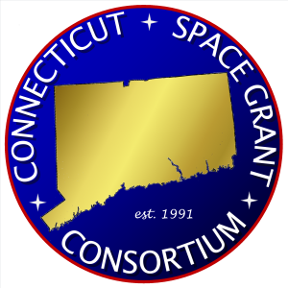

NASA CT SPACE GRANT CONSORTIUM

K-12 Grant Application

Project/Event Title:
Project/Event Description: (250 word maximum)

Applicant Contact Information:
Name:
Title:
School/District:
Email:
Phone:
Address:
City/State/Zip Code:

Project/Event Activity Date(s) (mm/dd/yyyy):
Start Date: |  | End Date:

What is the expected duration of project/event:
☐ Short Event (< 2 Days) ☐ Long Event (>2 Days)
☐ Multi-Month (Semester/ Quarter) ☐ Year-Long (12 Months)

Location of Project/Event:
Name:
Address:
City/State/Zip Code:

Enter the anticipated number of participants that will participate in project/event:
Participant Type | Count | Participant Type | Count
Elementary School Teachers |  | District Staff
Middle School Teachers |  | Parents
High School Teachers |  | Community Members
Elementary School Students |  | Higher Education
Middle School Students |  | Other
High School Students
Total Participants

Describe the involvement of higher education students and faculty in this project/event (if applicable):

Provide a timeline for this project/event:

Complete budget (see Appendix A) and include a brief narrative of expenditures and in-kind contribution(s). Please note: the budget should provide at minimum a 1:1 match (direct or in-kind); for example, if you are requesting $500 in funding, a minimum $500 match should be provided by school/district:

Applicant Name: |  | Date:
Applicant Signature:
Department Chair/Principal/  Superintendent Name: |  | Date:
Department Chair/Principal/
Superintendent Signature:

Appendix A: Budget

Item | Request | Match | Total
Salary/stipend
Equipment | Not permitted
Supplies
Transportation
Facility rental/usage
Food
Other (please specify)
Total

Submission Instructions:
- Complete K-12 Grant Application
- Provide a letter of support on letterhead from one of the following individuals: department chair, principal, or superintendent
- Combine K-12 Grant Application and letter of support into one PDF file and email it to ctspgrant@hartford.edu

Important Information:
- Applications priority deadlines are December 1st (for award period January 1st to June 30th) and June 1st (for award period July 1st to December 31st); applications received after priority deadlines will be reviewed on a rolling basis and awarded if funds are available
- You should receive notice of award within one month of submission
- If awarded, you can anticipate receiving funds approximately 6-8 weeks after submission
- You must prepare a short post-award description of the outcomes of the project/event

